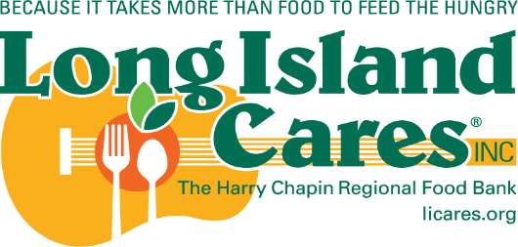

Long Island Cares, Inc. -
The Harry Chapin Food Bank
2026 - 2027 Application Checklist

Application Priorities Check List
Please tell us what 2026-2027 HPNAP grant applications you will be applying for:
YES NO
Food Support Grant ☐ ☐
Operation Support Grant ☐ ☐
Capital Equipment Grant ☐ ☐

If you are applying for both Operation Support and Capital Equipment Grants you must select a grant application priority below due to the competitive nature of these grants. In the event you can only be awarded one of the grants we would like to know which grant is most needed and desired for your agency.

1st Priority Application
Capital Equipment Grant Choose an item.
Operation Support Grant Choose an item.

Please utilize this checklist to verify that all necessary documents are included in your application packet.

An incomplete application form will result in a lower score and may disqualify the agency's request.

- Required for all Food Grant Applications
☐ HPNAP 2026-2027 Food Grant Application
- Carefully complete all necessary pages.
- HPNAP Agreement Form, pages 13 & 14 application must be reviewed and signed.

- Required for all Operations Grant Categories
(For Staff, Utilities, Space or Disposables)
☐ HPNAP 2026-2027 Operations Grant Application
- This application is 14 pages long.
- Carefully complete all necessary pages. The person submitting the application must sign & date page 14.

Required for a Staff Request
Include One of the Three Options Below
Documentation must be from the period of January 1, 2025 – December 31, 2025
☐ Copies of the payroll register (3 payroll periods).
OR
☐ Copies of timecards/time sheets showing days and hours
worked, and copies of the canceled pay checks (3 payroll periods).
OR
☐ Copies of 1099 or W-2 forms.
Required for a Utility Request
Documentation must be from the period of January 1, 2025 – December 31, 2025
☐ Six (6) months of utility documentation
Copies of utility bills and copies of canceled checks for one type of utility (heat, electric or gas).
- Budgeted and balanced billing cycle bills are not acceptable.

Required for a Disposables Request
Documentation must be from the period of January 1, 2025 – December 31, 2025
☐ Copies of receipts for eligible items purchased (do not send physical receipts).
Required for a Space Request
Documentation must include the period of December 2025
☐ Copy of your Current signed Rental Agreement, Lease, or User Fee Agreement from your landlord, organization, or lessor with this agreement.
- Expired lease, rental documents will not be accepted, and your application will be denied.

Capital Equipment Grant Application

Required for Capital Equipment
☐ HPNAP 2026-2027 Capital Equipment Grant Application
- This application is 7 pages long.
- Carefully complete all necessary pages.
- The person submitting the application must sign & date page 7.

Please mail completed application to:
Long Island Cares, Inc. – The Harry Chapin Food Bank
HPNAP Advisory Committee
10 Davids Drive
Hauppauge, NY 11788

